***Assignment 3:***

1. pwd:  
   command prints the absolute path to current working directory.

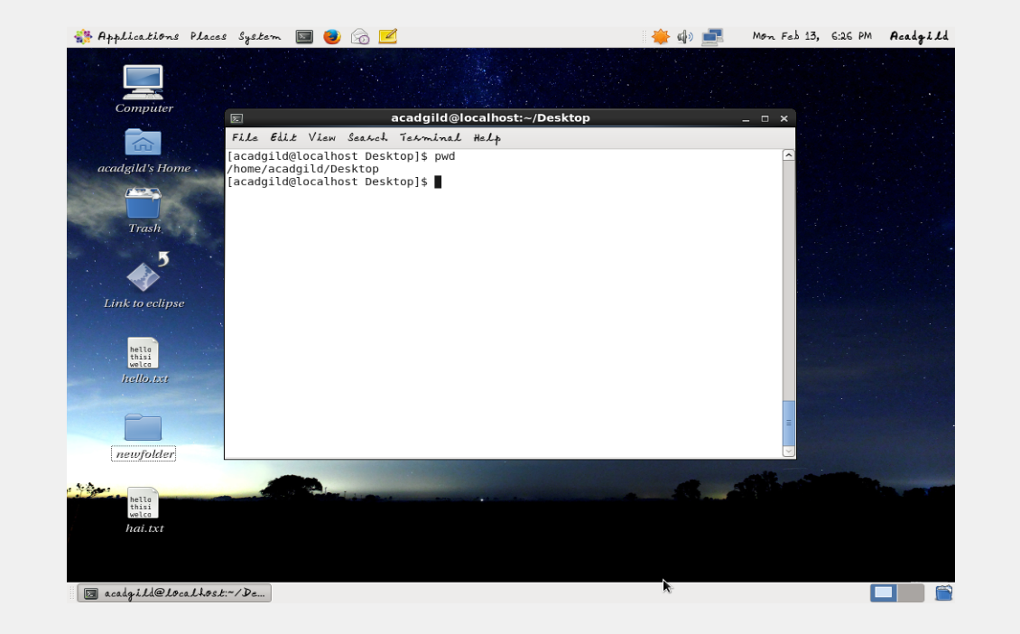

1. VI:
   1. The VI stands for Visual editor; another text editor in Linux. This is a standard editor in many Linux/Unix environments. This is the default editor that comes with many Linux distributions.  
      The vi editor has 3 modes in which it performs its functions.
   2. -The default is COMMAND mode, in which tasks like copy, paste, undo etc can be performed. You can change a mode from command mode only (and come back to it).
   3. -The second mode is the INSERT mode, in which whatever key you type is treated as a character and will be loaded into the file buffer. To enter this mode, press ‘i’ when in command mode.  
       -Final mode is EX mode or last line mode. The changes made in the buffer can be saved or discarded in this mode.  
      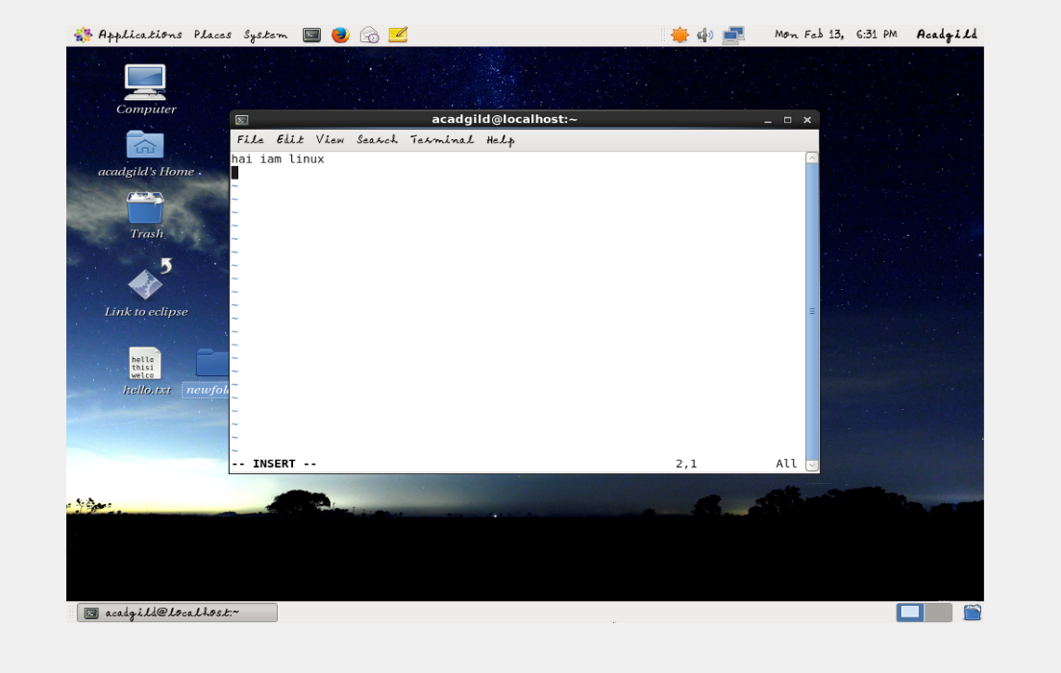
2. touch:  
   The touch [command](http://www.linfo.org/command.html) is the easiest way to create new, empty [files](http://www.linfo.org/file.html). It is also used to change the timestamps (i.e., dates and times of the most recent access and modification) on existing files and [directories](http://www.linfo.org/directory.html).

Eg: touch file1 file2 file3

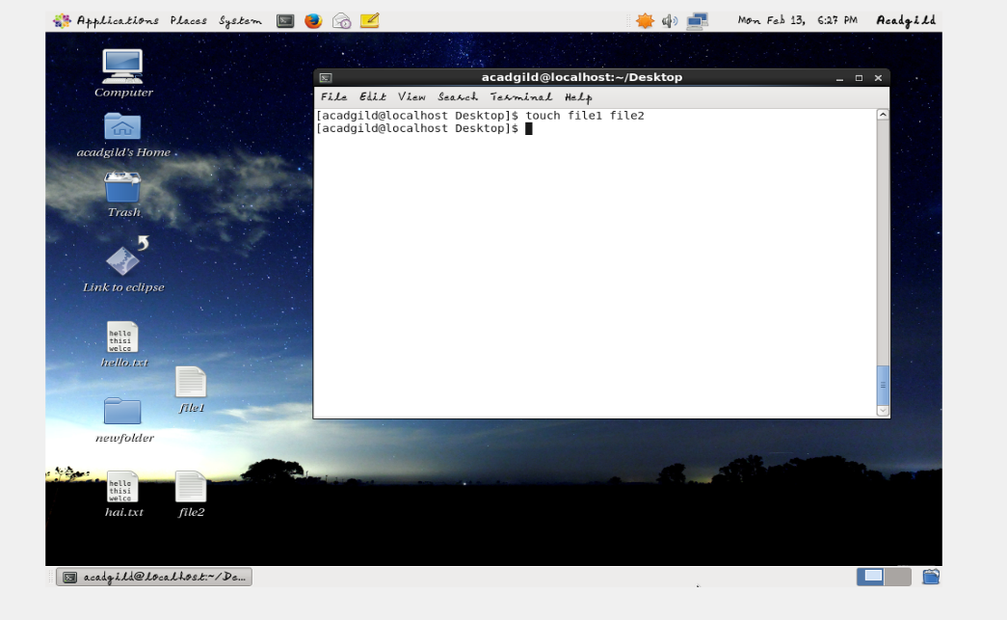

1. mkdir:

To create a directory, the ‘mkdir’ command is used.

Eg: mkdir newfolder

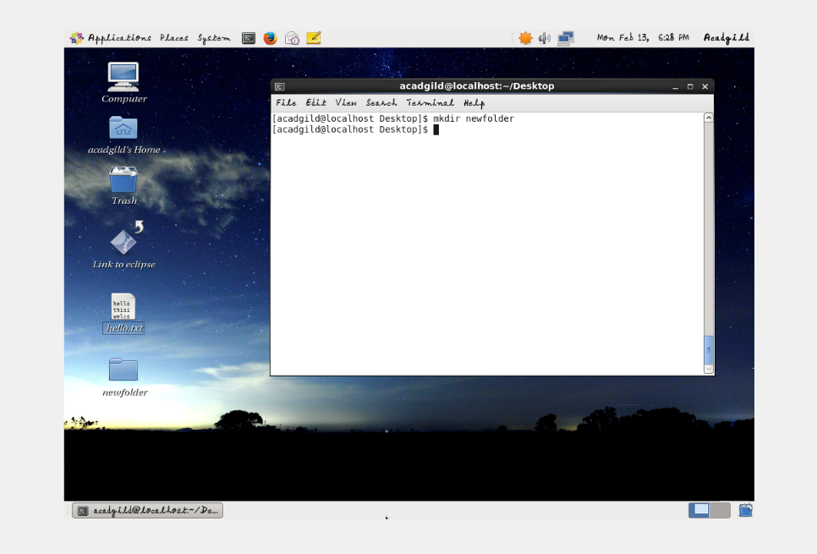

1. rm :

'rmdir' command removes any empty directories, but cannot delete a directory if a file is present in it. To use ‘rmdir’ command, you must first remove all the files present in the directory you wish to remove (and possibly directories if any).

Eg: rm newfolder

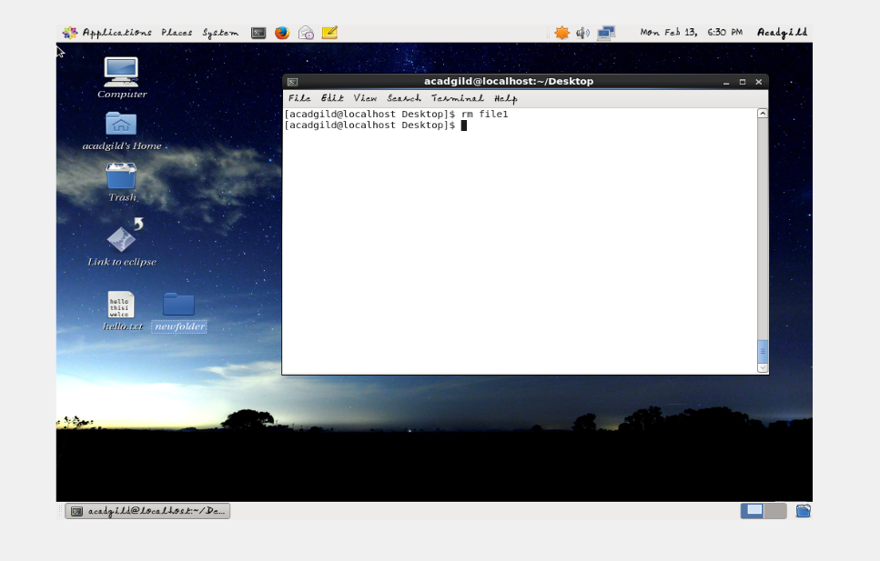

1. ls:

List files and/or directories. If no argument is given, the contents of current directory are shown.  
eg: ls –l

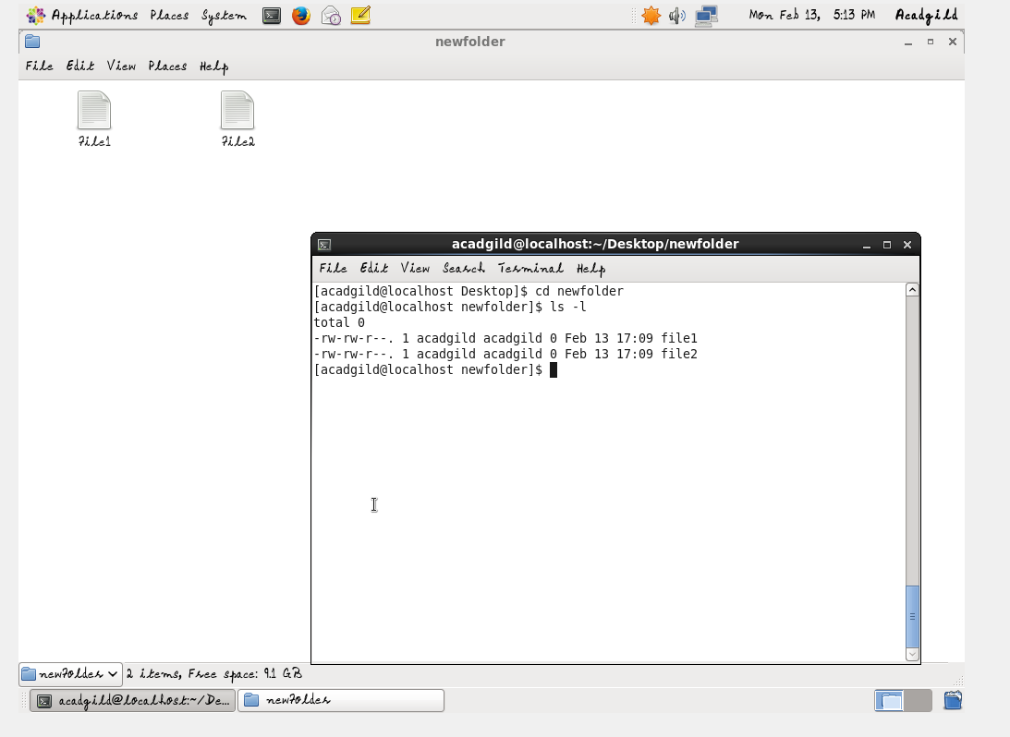

1. echo:

This command will echo whatever you provide it.

Eg: echo WELCOME TO LINUX

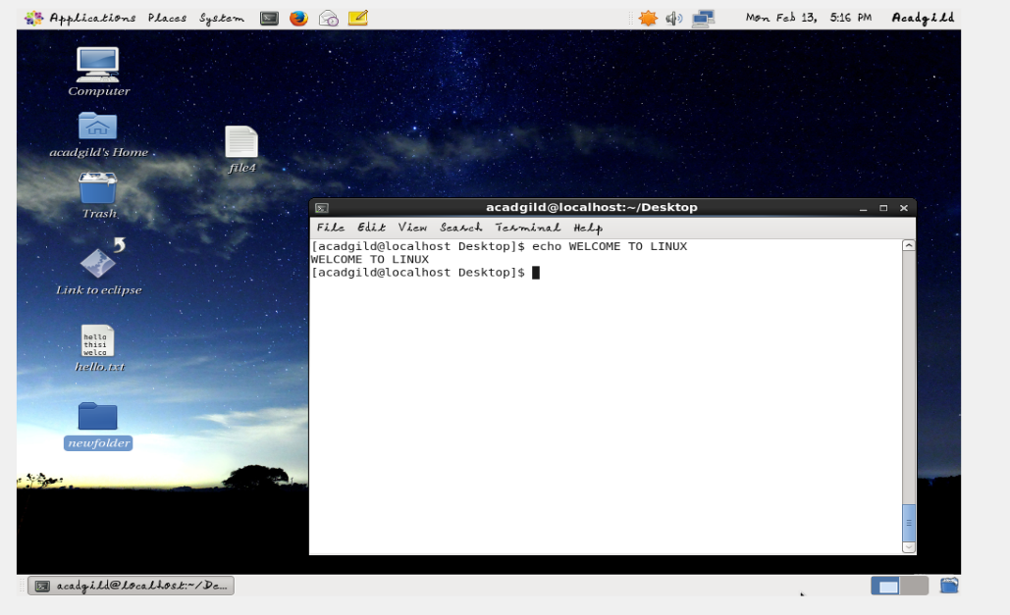

1. cat:

The 'cat' command is actually a concatenator, but can be used to view the contents of a file.

eg: cat hello.txt

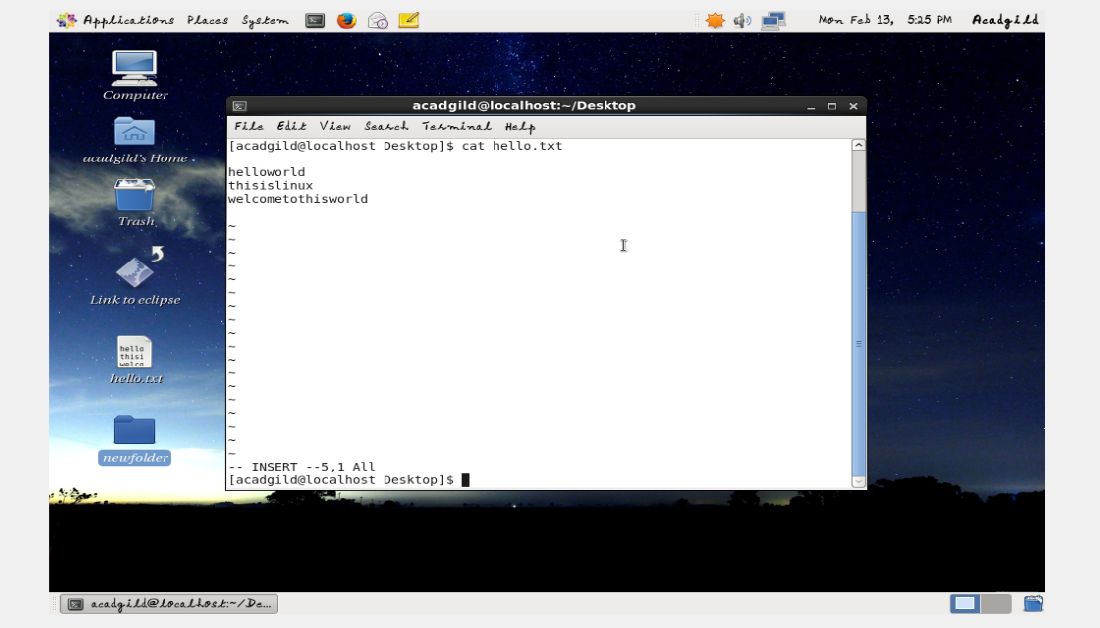

1. who:  
   **who** command is a tool print information about users **who are currently logged in**  
   Eg: who  
   the above output get the information on currently logged in users.  
   Eg: who –b

The above output gives the exact date and time of last system boot.

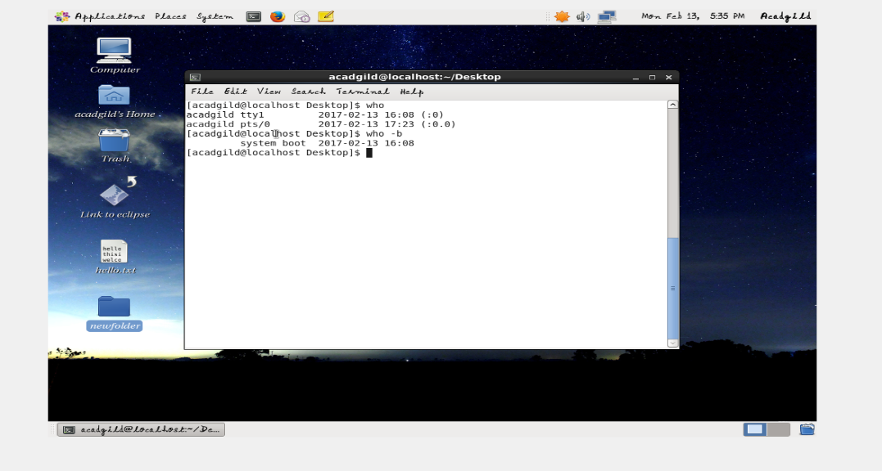

1. cd:  
   The cd [command](http://www.linfo.org/command.html) is used to change the [current directory](http://www.linfo.org/current_directory.html) (i.e., the [directory](http://www.linfo.org/directory.html) in which the user is currently working)

eg: cd

eg: cd Desktop

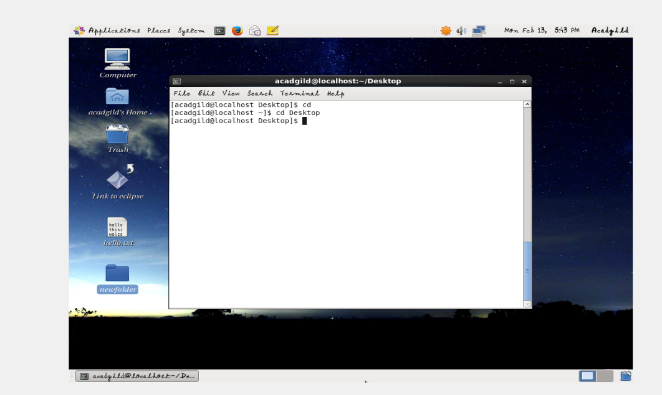

1. date:

Displays current time and date.

Eg:date

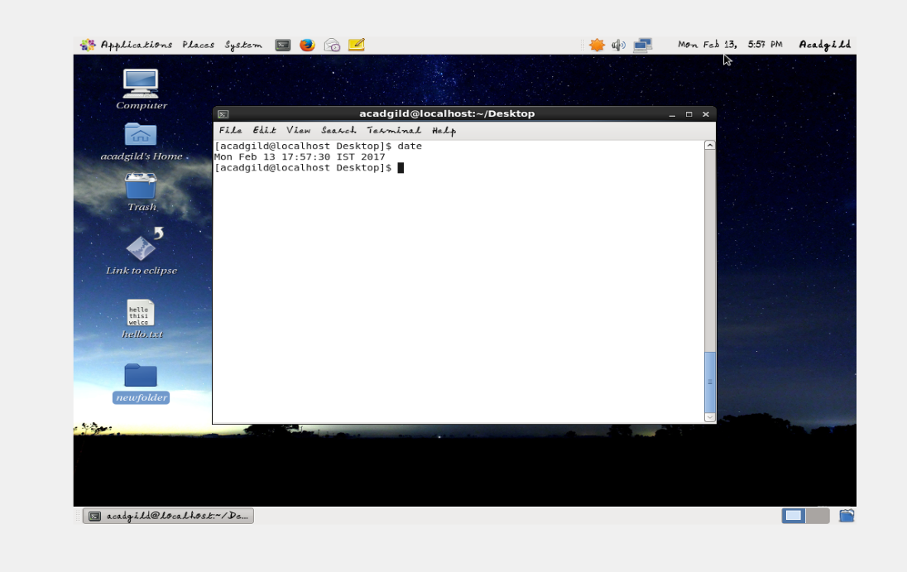

1. cal:

Displays the calendar of the current month.

Eg: cal

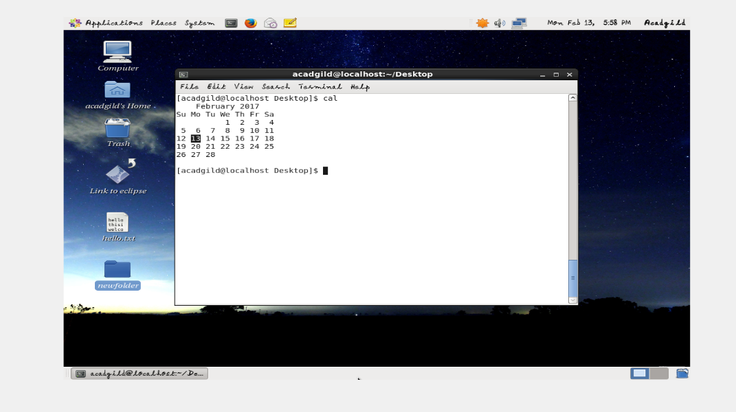

1. mv:  
   Move files or directories. The 'mv' command works like 'cp' command, except that the original file is removed. But, the mv command can be used to rename the files (or directories).

Eg: mv testfile testfile2

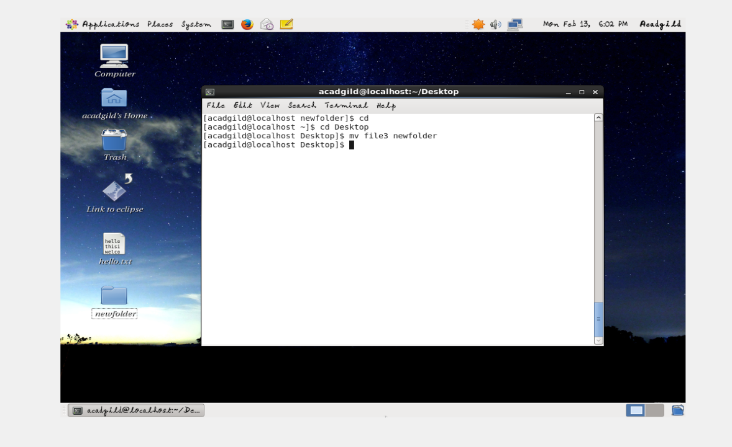

1. cp:  
   Copy files and directories. If the source is a file, and the destination (file) name does not exit, then source is copied with new name i.e. with the name provided as the destination.

Eg: cp hello.txt hai.txt

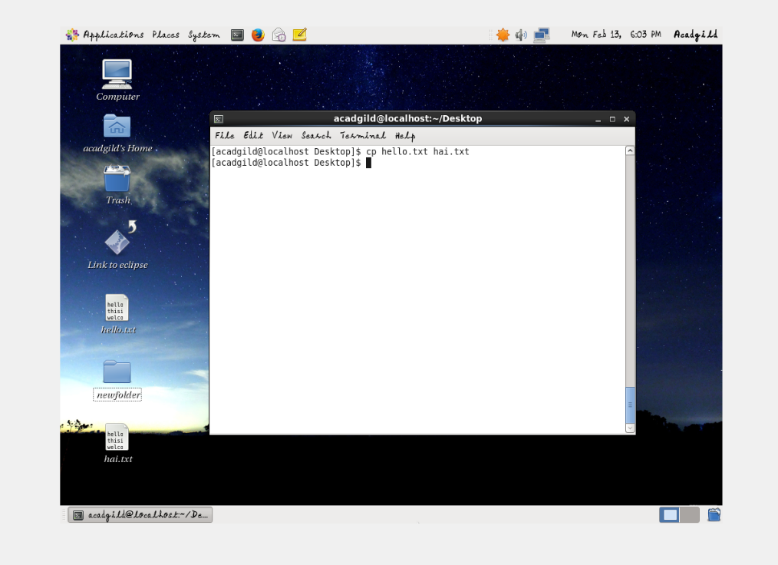

1. which:

This Linux which command is used to find the location of a program.

Eg: which firefox

